

**Strengthening Individuals, Families, and Communities in Todd, Tripp, Mellette, and Gregory Counties.**

**SOUTHERN PLAINS BEHAVIORAL HEALTH SERVICES**

**AG CRISIS SUPPORT PROGRAM**

**500 E 9th St.**

**Winner, SD 57580**

**Satellite Offices in Gregory, Mission, and White River**

Individuals and families who are engaged in agri-business tend to have a strong work ethic and sense of pride. While admirable, these traits can also lead to the avoidance and denial of situations that might include:

• Concerns about weather

• Uncertainty over markets

• Frustration with bureaucracies

• Financial stress

• Relationship Problems

• Feelings of dread or hopelessness

• Increased substance use

• Serious problems such as depression and suicide

Faced with increased stress, physical, emotional, social and spiritual self-care all become of critical importance.

If you were impacted by recent flooding and severe storms, you may be experiencing:

• anxiety and vigilance

• anger, resentment, and conflict

• uncertainty about the future

• prolonged mourning of losses

• diminished problem-solving

• isolation and hopelessness

• health problems

• physical and mental exhaustion

• Can’t remember things

Ag Crisis Support Program addresses:

• Stress

• Change / adjustment issues

• Depression

• Anxiety

• Hopelessness

• Relationship changes

• Marital and family problems

• Substance use

• Suicide

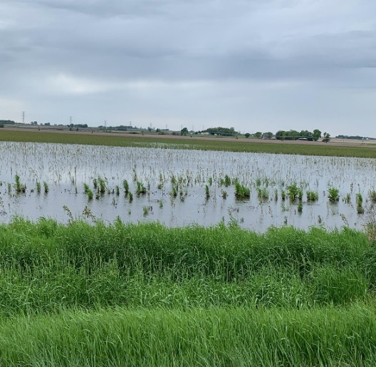

**SERVICES:**

 Crisis services are available 24 hour / 7 days per week by calling telephone number (**605) 842-1465**. A qualified professional is available by phone or arrangements can be made for emergency face to face care.

**National Suicide Prevention Lifeline**:

**1-800-273-8255**

**Avera Farm and Rural Stress Hotline:**

**1-800-****691-4336**

**COST OF SERVICE**

Crisis services are free of charge and individuals can receive up to three individual appointments at no cost.

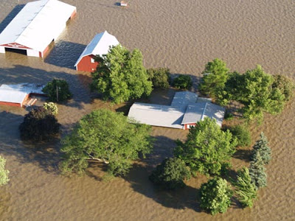

***The Healing Power of Grief***

The Uphill Climb: Recovery

Everybody has their own individual time table for grief. Some people may go through the rest of their lives angry with the unfairness of the event. With support and guidance, however, most people are able to move beyond these feelings.

Fortunately, grief can be one of the most healing experiences we can go through. People can learn valuable lessons from adversity.

***Lessons learned might include:***

*Reframing the meaning of life and setting priorities; finding larger purposes, value and meaning to life

*Realizing the importance of relationships—that helping others may be a way to “repay” the help received

*The positive power of connection to our neighbors and communities

*The qualities of strong families; which include commitment, appreciation, communication time, coping and spiritual wellness. The need to say thanks and the benefits of celebration

***Tips to ensure you are ready for the uphill climb!***

 1.) Get plenty of rest.

2.) Take time for yourself.

3.) Talk to someone if you are feeling

overwhelmed.

 nlcu]]

***The Effects of Prolonged Stress***

The Down Hill Slope: Prolonged Stress

Natural disasters often lead to prolonged emotional and physical stress. During times of extreme stress, people experience varying stages of emotions. Alarm or shock is often the first stage, followed by resistance (denial) and then exhaustion.

 Exhaustion, fear, anger, disillusionment, cynicism and depression are common. These responses are normal and appropriate for something (a home, a farm, a business, a dream) which is lost over a long period of time.

***Negative results of prolonged stress include:***

* Difficulty falling or staying asleep
* Nightmares
* Irritability; outbursts of anger
* Excessive drinking/drug use
* Difficulty concentrating
* Excessive worry, hyper vigilance or extreme concerns
* Re-experiencing the event
* Guilt and self-doubt
* Withdrawal and suspicion
* Sudden painful emotions
* Apathy, avoidance of emotions, activities and situations associated with the event